WEEK 9 LEARNING OUTCOMES

Upon completion of this session, students should be able to:
- Understand the use and application of HTML5 Structural Elements
- Convert existing nested DIV structures to HTML5 Structural Elements
- Use HTML5 Video element to embed a video file into your HTML pages
- Use width and height attributes to set the dimensions of your video
- Use the control attributes to add browser generated control options
- Use the src attribute to specify alternative file types
- Use HTML5 Audio element to embed an audio file into your HTML pages
- Use the control attributes to add browser generated control options

Wherever possible, you should try to use tags in compliance with the specification for HTML 5.

Within, this document, tags are shown in capitals for purposes of clarity and emphasis.

TASK 1: HTML5 STRUCTURAL ELEMENTS Page 2

TASK 2: STRUCTURAL ELEMENTS / CSS RULES Page 3

TASK 3: CHILD ELEMENTS / STRUCTURAL PARENTS Page 4

TASK 4: ADD HTML5 VIDEO Page 5

SELF-STUDY TASKS FOR WEEK 9 Page 6

TASK 1: HTML5 STRUCTURAL ELEMENTS

The diagram below represents the kind of structures that we have been working with. Using HTML structural elements, we should seek to replace DIVs that use IDs (generally with a name that alludes to its use like #header) with semantic structural markup using HTML5.

1). Use the HTML5 structural elements within a new wrapper div structure.

2). Replace existing DIV sections (which are using IDs) with structural elements.
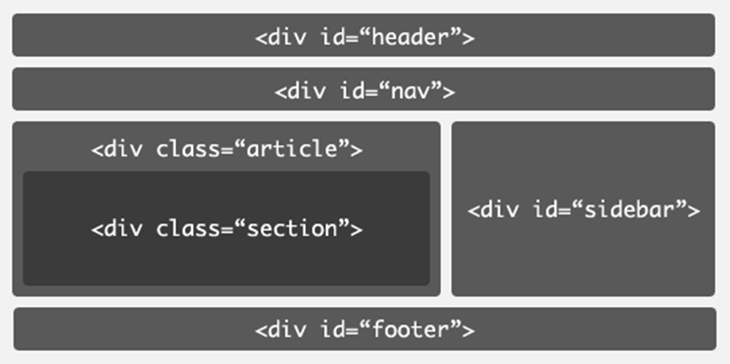
REPLACE WITH HTML5 ELEMENTS
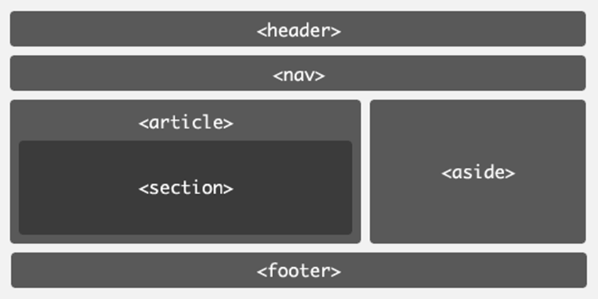
NB You do not have to exactly recreate the structure above, moreover, you should try to use the new HTML5 structural elements to recreate your own nested DIV structure. This may take a little bit of experimentation.

TASK 2: HTML5 STRUCTURAL ELEMENTS AND CSS RULES

One of the issues you will face when converting existing DIV structures is attaching the CSS which was attached to DIVs using IDs and classes. You can use your existing CSS rules to add the same formatting and positional properties to HTML5 Structural Elements.

1). Remove any remaining DIVs which allude to structure (e.g. #header)

2). Migrate CSS rules from DIV IDs and classes to structural elements.

2). Apply existing and/or new rules to Structural Elements.

#header {
padding: 10px;
height: 150px;
width: 95%;
margin-top: 10px;
margin-right: auto;
margin-bottom: 10px;
margin-left: auto;
border: 1px solid #999;}
DIVS CONTROLLED WITH ID SELECTORS |  | CSS FOR HEADER DIV
header {...}
nav {...}
article{...}
section{...}
aside{...}
footer{...}
STRUCTURAL ELEMENTS WITH CSS APPLIED |  | CSS FOR STRUCTURAL ELEMENTS
NB You need to be careful here as you may incur clashes in terms of the declarations which you are seeking to apply. Make sure that you have eliminated all primarily structural DIVs (if it has an ID that has a structural name like #header) and that the CSS is now attached to the structural elements and not any remaining structural DIVs.

TASK 3: ADD CHILD ELEMENTS WITHIN STRUCTURAL PARENTS

You can still use classes and IDs but these should now be applied to DIVs that reside within the HTML5 Structural Elements. You can also use descendent selectors to target other elements within the HTML5 Structural Elements.

1). Add navigational elements (<a>) within <nav> as part of an unordered list.

2). Style the links within the unordered list using descendent selectors.
<body>

<div id="wrapper">

<header><h1>THIS IS WEEK 9 OF CT4009 </h1> </header>

<nav>
<ul>
<li>LINKS WILL GO IN HERE</li>
<li> LINKS WILL GO IN HERE </li>
<li> LINKS WILL GO IN HERE </li>
</ul>
</nav>

<article> THIS IS WEEK 9 OF CT4009</article>

<footer>THIS IS WEEK 9 OF CT4009</footer>

<div id="footer2">THIS IS WEEK 8 OF CT4009</div>

</div>
</body>
</html>
DESCENDENT SELECTORS FOR CSS |  | EXAMPLE CSS FOR LINK
nav {...}  nav ul{...}  nav ul li{...}  nav ul li a{...} |  | nav ul li a{  font-size:14px;  height:22px;  line-height:22px;  text-align:center;  text-decoration:none;  width:100px;}
NB In the example above, there are two footers, only one of which can use the <footer> element. The other is an ordinary DIV with an ID of footer. The example CSS should be amended to include pseudo selectors (LVHA).

TASK 4: ADD HTML5 VIDEO

1). Use the HTML5 <video> element to embed video.

2). Specify dimensions and default controls.

3). Specify file types and fallback (download link).

<body>

<div id="wrapper">

<header><h1>THIS IS WEEK 9 OF CT4009 </h1> </header>

<nav></nav>

<article> <section>EMBED VIDEO </section></article>

<footer>THIS IS WEEK 9 OF CT4009</footer>

<div id="footer2">THIS IS WEEK 9 OF CT4009</div>

<video width="291" height="300" controls>
<source src="blink_led_24.mp4" type="video/mp4">
<source src="blink_led_24.ogg" type="video/ogg"></p>
</video>

</div>
</body>
</html>
EXAMPLE HTML5 VIDEO API | POSSIBLE VIDEO FILE TYPES AND OTHER ATTRIBUTES
<video src=“myVideo.mp4”  width=320  height=240  controls  poster=“myVideo.jpg”>  Download the video in <a href=myVideo.ogg>Ogg</a> or <a href=myVideo.mp4>MP4</a>  format  </video> | MP4: MPEG 4 files with H264 video codec and AAC audio codec  WebM: WebM files with VP8 video codec and Vorbis audio codec  Ogg: Ogg files with Theora video codec and Vorbis audio codec  Autoplay  The browser will automatically play a video.  Autobuffer  If you are sure that users want to watch a video but you don´t want to use autoplay, the autobuffer attribute will prompt the browser to automatically load the video in the background.
SELF-STUDY: CONDUCT FURTHER EXPERIMENTS WITH POSITIONS AND CSS3.
1). Upon Completion of tutorial tasks, experiment further with HTML5 Structural Elements and apply CSS to control them and the content which they contain. You should do this using descendent selectors and also CSS3 Structural Selectors (Week 8), to target child elements and non-elements within the structure.

2). Continue to experiment with HTML, adding further content (text and images) to your documents. You should now seek to add video and audio to your portfolio using the techniques outlined during this session. This should now take place as part of your Portfolio Website.

3). Experiment with the formatting possibilities of CSS, demonstrating these differences and illustrating the techniques within your HTML.

4). Use these tools and techniques to create initial prototype layouts for you portfolio site.
Good introductory material and practical exercises can be found at:
http://www.w3schools.com/css/default.asphttp://www.csszengarden.com/ http://meyerweb.com/eric/css/edge/
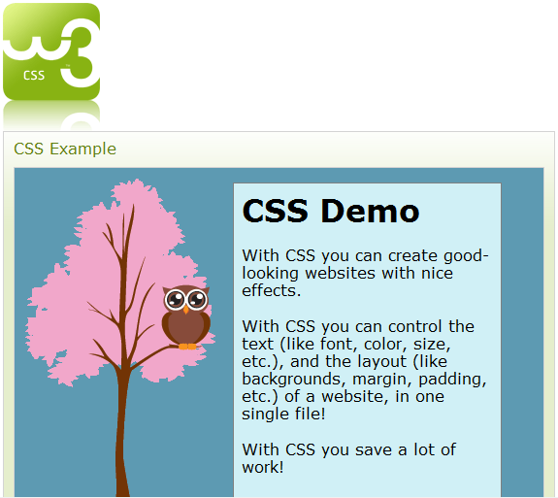
You should also take screengrabs of your HTML, the CSS which you create and the resultant documents (as rendered via a browser) and integrate these into Evaluation Document. The illustration and discussion of code can be difficult to present effectively, so ensure that you have looked at the Evaluation Document Guidelines available on the module website.

If you have successfully completed the Tutorial Exercises, you could spend the remaining study time reading the recommended textbook. Alternatively, you could review this week’s lecture notes or look ahead to next week’s topics. Remember that you are free to use the labs as long as they are not booked for another lesson; they tend to be very quiet early in the morning and in the evenings!

It is important that you read through the module guide several times throughout the semester so that you have a thorough understanding of the requirements of the module, particularly the assignments.

Starting planning your portfolio for assignment 1 by considering things such as what media you may already have that could be included, e.g. photographs etc. Are these available locally? Do they need to be scanned or digitised? If you do not have your own digital camera or camcorder you should think about borrowing these from the technicians – plan for this by booking in advance. Also, it would be appropriate to keep a written diary of your html / authoring experiences so that you can use them later on in the assignment and include them in your Evaluation Document. This could be rough notes, sketches or possibly screen shots, add to them as thoughts come to mind – it is too easy to forget excellent ideas you had late at night or early in the morning!

NB: If you did not manage to complete all of the tutorial exercise in the time available during your allotted lab session, you must endeavor to catch up during the self-directed study time.

